Personal Kiosk Project—Advanced Computer Applications (PowerPoint)
As you approach this self-running, timed presentation, consider how this should NOT look like a traditional PowerPoint presentation. As a matter of fact, when finished, it will be exported as a video file to be viewed in Windows Media Player! There will be no clicking (other than Play!). Your goal:
- Teach me something “star quality” about yourself
- Give me some FACTS (if you are a video game star, it could be all about that… or a mix of things)
- Tell a personal story through fast-moving imagery
- Keep me entertained
- Make it professional (think “infographic” and visual and less “text” and PowerPoint-y)
Here is an example “infographic” presentation about infographics! This type of “look” is what you are after. Stick with simple images or photographs that are in frames or shapes.
https://www.youtube.com/watch?v=6-qbf5lsFH0
EXAMPLE PRESENTATION http://
NOTE: Example is 15 slides and 1:16 in length (must have 8 slides and at 30 seconds to 2 minutes long)
Example of labeled slides (just first page) 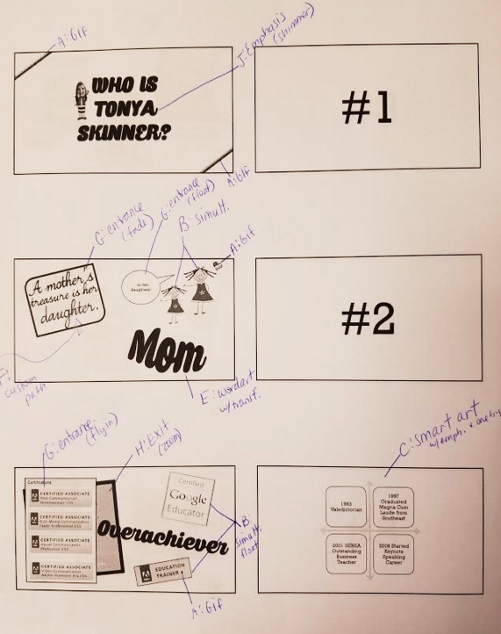

PERSONAL KIOSK POWERPOINT SCORING GUIDE Name:________________________
Requirement | Points Possible | Deducted
Required “background music” is used and plays throughout and volume is suitable (Insert, Sound, make sure it plays first, and set to “Start Automatically” and “Play Across Slides” so it plays for the duration)  http://incompetech.com/music/royalty-free | 5
Song speaker icon is dragged off the slide or is not visible (can check Hide During Show) | 3
2 animated gifs/movies are used (waving flags, fireworks, decorations, bullets, etc.)  **Set Google search tools to Type Animated  **Helpful site http://www.wilsoninfo.com/ *Must save and insert; no copy/paste | 6 | A
Good balance of quality clipart with infographics and/or photographs | 9
White clip backgrounds are modified to be transparent if not used with a border (Picture Tools, Format, Recolor, Set Transparent Color, click white area) | 3
Quality of artwork/pictures (no blurry, oversized, or watermarked art)  **This should be professional! | 10
At least 2 instances (two different slides) of “simultaneous action” are used (Custom Animation, Start With Previous; example would be more than one thing coming in from different sides of the screen at the same time) | 6 | B
Text is incorporated in a way that adds to the overall presentation and not as standard bulleted lists more than once; appropriate use of fonts/color and correct spelling/grammar and capitalization | 13
Use of one SmartArt graphic with emphasis animation applied and one-by-one effect option | 5 | C
Image of student used inside a shape (crop to shape) with border | 5 | D
WordArt used with text transform effect applied | 5 | E
1 custom animation motion path used –“special” or “custom drawn path” | 5 | F
3 entrance animation effects are used | 9 | G
3 exit animation effects are used | 9 | H
2 emphasis effects are used | 6 | J
Use of slide transitions to create interest | 8
Suitability of timing to content (Rehearse Timings and click through) | 10
Fast-moving throughout presentation; avoid moments of “stillness” other than for a few seconds to read | 10
Overall quality/content and professional appearance ** MUST BE AT LEAST 30 SECONDS AND MINIMUM 8 SLIDES IN LENGTH; no longer than 2 minutes ** | 15
Name is included on final slide in bottom right corner, script style font | 2 | M
Music trimmed to rehearsed length and fades out at least 3 seconds  **Compress Media before exporting; if you can’t tell how long, export it so you know exact time and then trim to that length with a 3 second fade out and re-export | 6
TOTAL PROJECT ** 10% deduction if project is too short or too few slides | 150
FINAL PROJECT SHOULD BE SAVED TO VIDEO FILE  File> Export > Create a Video (set to use recorded timings) |  | Submit video by USB and to Shared Google Folder
indicates this must be noted on the printout for grading
Finishing Up: When finished, print your slides 6 per page as handouts (preview first!!!). Then, identify each item on the scoring guide labeled with the pencil on the slides to make it easier for me to locate the requirements (show where you used animation gifs, custom animation, simultaneous action, exit effect and which one, etc.). Use the LETTER and short description to identify and note the specific animation effects used, where applicable (zoom in, etc.).
The assignment WILL NOT be graded if this is not labeled. STAPLE PRINTOUT TO SHEET

